Cash Jukebox 2.0

Introduction

Welcome to Cash Jukebox 2.0 the hugely anticipated follow up to Cash Jukebox 1.0. In the first Cash Jukebox we found out how to set up and ebay account, an amazon account, how to list your items for sale and how to use your own CD's and DVD's to create some fast cash.

In Cash Jukebox 2.0 we are going to take your shiny new business to the next level. This will make you a lot of money if you follow the instructions and get on with it!



The Right Attitude

I have been in business in one form or another for over 30 years. I have seen great ideas and bad ideas come and go. Some great ideas went on to make millions and some bad ideas went on to make money too!

The one key element is taking action.

Whether your business idea is good or bad if you don't do anything about it then it won't make any money will it?

So I took action with this business idea and make a lot of money from it. I have done the hard part for you – come up with a great idea that works. I have proven to you that it works within this guide and even given you my suppliers and lists of rare items so you can snap them up for pennies and sell them for huge profits.

None of this is any good unless you get started and just do it!

If you haven't gone through the first guide yet then do so now before you start this one. If you haven't got a copy of the first one then email me now at pearlydean@gmail.com and I will send it to you.

Make this your year and make a success of your life...please!!

Best regards
Keith Dean

Let's Make Some Money

OK time to get to work.

So you should be at the stage where you have an ebay account, an amazon account and have listed some of your own items. One reason for listing your own items is to get good feedback. 100% feedback is paramount to ensure that you get the most sales and at the highest prices.

We now need to go through the techniques that I use to maintain my 100% feedback rating over all of my accounts since 2003.

The 12 Special “Money Magnet” Techniques

Money Magnet One - Ebay Alerts
Money Magnet Two - Amazon Advanced Search
Money Magnet Three - Mis Spellings
Money Magnet Four - Listing Search Terms
Money Magnet Five - Protect Your Feedback At All Costs
Money Magnet Six - Sell Your Own Stuff First
Money Magnet Seven - Research Prices And Movers
Money Magnet Eight - Get Paid Fast – Reinvest Your Profits
Money Magnet Nine - Be Businesslike And Professional
Money Magnet Ten - Checks To Do Before Buying Stock
Money Magnet Eleven - Make Lists – Lock In Future Profits
Money Magnet Twelve - Buy In Bulk To Make Big Savings and Huge Profits

Money Magnet One – Ebay Alerts

This is a way of getting ebay to do some of the work for you when looking for collectable CD's or DVD's. As we saw in the last section not every search you perform in Amazon will yield a result in ebay – but as some of these items are highly collectable then they won't come up very often.
To keep an eye on ebay for when these are listed would take you hours every day searching through the listings so what we do instead is set up an ebay alert:
Search in ebay for your item – in our example as before we look for Essential Mix Vol 1
The search is returned like this:
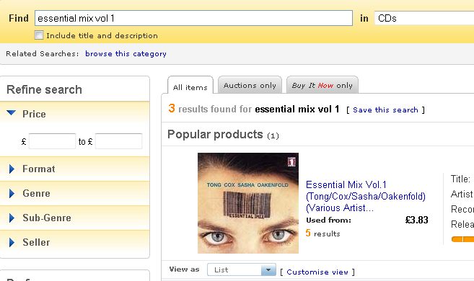

Now click on the Save this search link next to the 3 Results found and you will see this page:
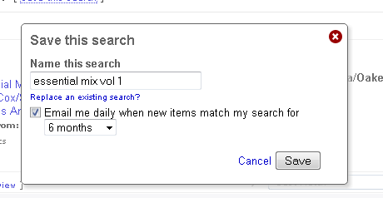
You can see the option to have ebay email you daily when new items match your search – you can choose for how long you want this anything from 7 days to 12 months.
This saves you so much time searching for items you want and you can configure your email folders to put these searches in so you don't overfill your inbox!
Here is one of the emails I receive:
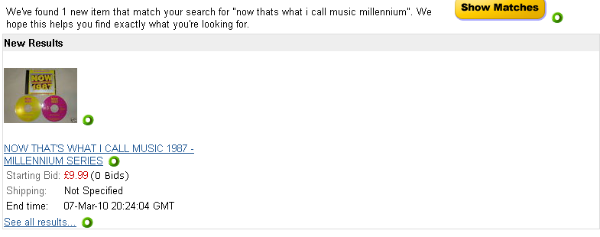
As you can see it isn't quite what I am looking for as the opening bid is for £9.99 but I receive many that have opening bids of 99p and also buy it now prices of £2.99 which I watch if its an auction or snap up if its a buy it now.

However here is a recent email with a bargain:
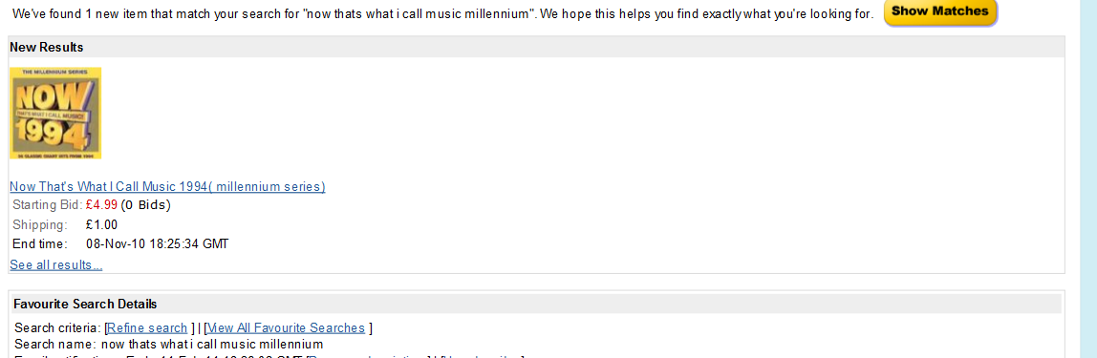
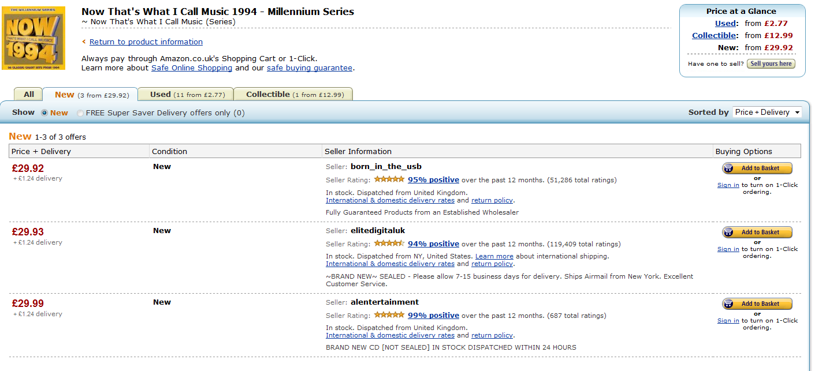
If I get this for the £4.99 starting bid then I can sell it for around £25 to £29 which is a great profit margin as you can see it is listed on Amazon at £29.92:

Of course I need to check that the CD on sale at ebay is in great condition so I can make the best price when I sell it on Amazon.

So set up some alerts when you find some products you are interested in and you won't ever miss a bargain....make sure you read the emails as soon as they arrive though!

Money Magnet Two - Amazon Advanced Search

I am going to show you a tip now that will help you to find the good priced items on Amazon and then you can nip over to ebay and see if there are any going cheaply there.
Amazon advanced search is an excellent tool for this and I will show you how to use it now:
Go to the Amazon home page then select Music and click go. This will bring you to this page -
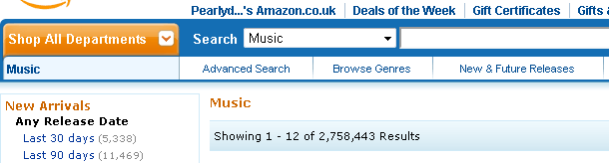
Now click on the Advanced Search tab...

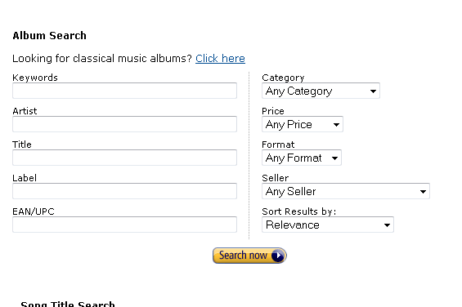

You can search in any combination here so just experiment a little with different combinations to see what you uncover.

I tend to look for Any Category/Price £20 -£30/Format CD/Seller Any Seller/ Sort results by Price High to Low as below:
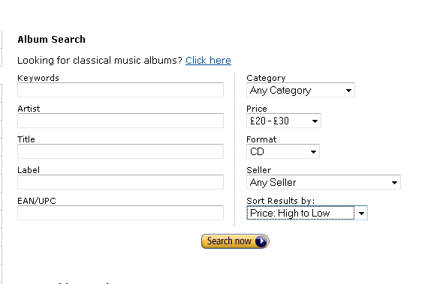
This gives me some good results:

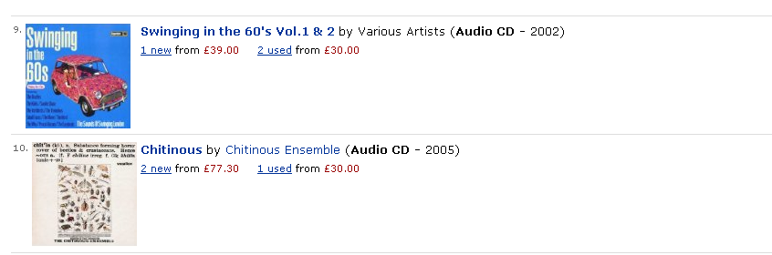

I can't find any listings for these two CD's in ebay yet but I will add them into my spreadsheet list under the tab “Potential CD's”.

Of course you can use ebay alerts to ensure that you know when one of these comes up for sale. Most people are unaware of the value of things – it's a case of what you know and if you use your new found knowledge you can buy some very rare items for as little as 99p.

Money Magnet Three - Mis Spellings
Look for mis-spellings or incomplete or brief listing titles. I used to miss out on so many bargains by
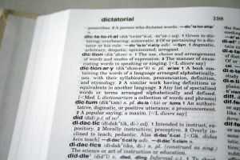
not doing this!

Only the other day I was looking for a copy of Now That's What I Call Music
Millennnium Series 1988 to complete a set of them.

I used to just search on the title in full but now also look for the variants such as Milennium, Millenium or simply Now Music 1988. I found one for £4.99 buy it now and it is now up on my Amazon listing for £19.99...good profit!

I also search for incomplete title such as Now Music, Now That's Music etc as not every seller lists them correctly which just points to the fact they do not know the true value!

Here is a great tool that I use to find misspellings:

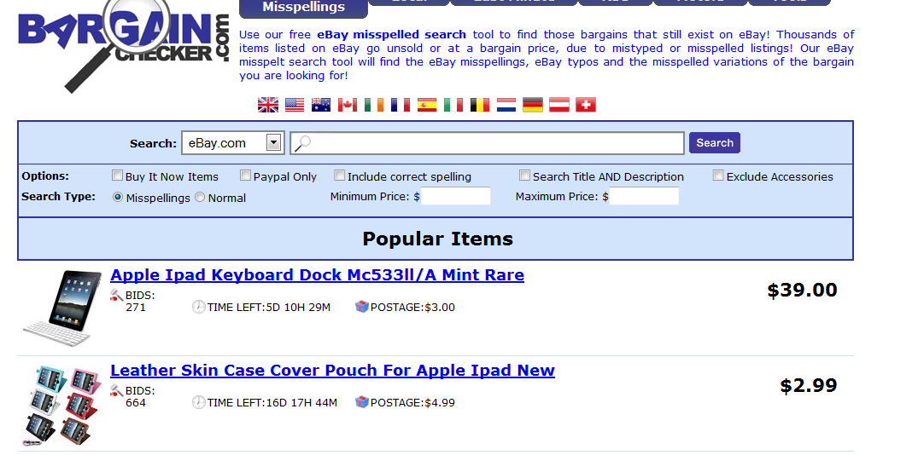
The website can be found at:

http://www.bargainchecker.com/

Money Magnet Four - Listing Search Terms

When listing your items ensure that you list accurately to get a better price.

If you are up against other sellers who just list as “good condition” or “UK version CD” or something just as brief you can get better sales by being more detailed.

You can use up to 2000 characters in your listing.

One example of a listing of mine is “Excellent condition 2 CD set - very light scratches on one CD but plays perfectly - insert and case in excellent condition - posted next day - please read my 100%
feedback comments to see the level of service I provide.”

This CD is for sale as £26.95 as the lowest price but I can confidently list at £29.99 and it will sell
within the next few weeks. An extra £3.24 isn't much but over 100 sales £324 is!

TOP TIP:
I just found out about this today and am very excited at the propects of bringing lost of people to my listings! It's a little like Google Adwords but just for Amazon. You have to register first so I am going to do that and see how good it is. I will email you once I know the cost and results. In the meantime here is the page:

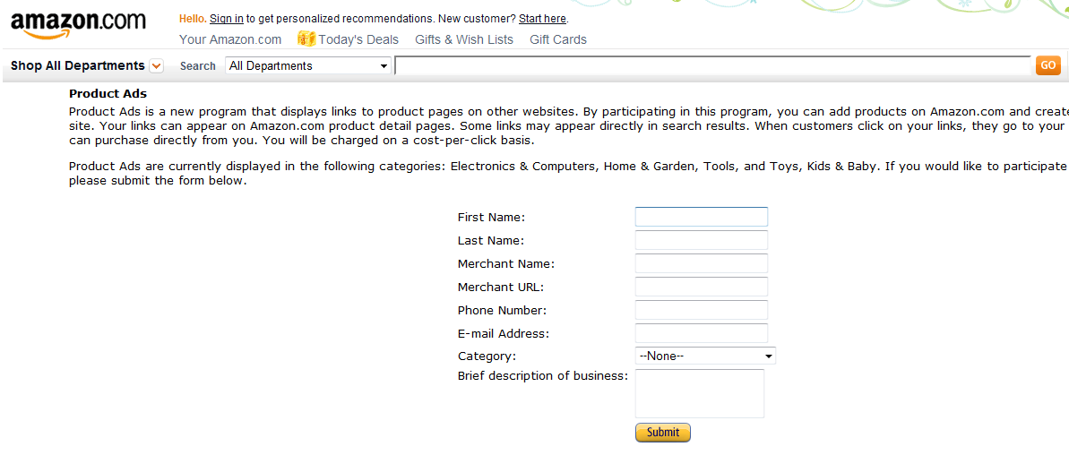

Money Magnet Five - Protect Your Feedback At All Costs

The only way to get the best prices and sell lots of items is to maintain a great feedback rating – at all costs. Even if you have to refund a buyer who you feel is trying it on then it is worth it. If you end up with just a few negative ratings on your seller accounts then people will just not buy from you – even if you are the lowest price.

I ask for customers to email me if they have any problems and even enclose a printed note with the item asking for good feedback if they are happy and to contact me immediately if they are not.

I can't stress this enough as you may feel annoyed at a buyer if they are being too fussy but it is only one sale and better to refund that one and maintain your 100% feedback so you attract many more sales.

5 out of 5: | "Very good seller. Item dispatched quickly"  Date: 2010/5/12 Rated by Buyer: Tony Parker
5 out of 5: | "The CD was delivered in time in an exelent way. I am very satisfied with this seller."  Date: 2010/5/11 Rated by Buyer: Tom Arne Moe
5 out of 5: | "Beautiful CD - So calming and Sent Fast and Secure. Very Well Packed and would definitely recommend this Seller! BUY WITH CONFIDENCE! Thank you."  Date: 2010/5/11 Rated by Buyer: L TRaynshaw
5 out of 5: | "no problems with the service so will use this site again."  Date: 2010/5/10 Rated by Buyer: Hilary
4 out of 5: | "Good Item and good price - smooth transaction - would recommend!"  Date: 2010/5/10 Rated by Buyer: Joely Smanatha Fray
5 out of 5: | "Very speedy just what we needed. Most impressive!"  Date: 2010/5/10 Rated by Buyer: Mrs Abigail Duignan
5 out of 5: | "arrived on time. good condition. cheers"  Date: 2010/5/10 Rated by Buyer: Miss Laura Connelly
5 out of 5: | "Excellent communication, excellent transaction, a pleasure to do business. A++++"  Date: 2010/5/10 Rated by Buyer: Lynda Eld)
5 out of 5: | "Arrived extremely quickly excellent condition will use again"  Date: 2010/5/10 Rated by Buyer: TINA BEAUMONT)

If you do come across a problem buyer then make sure you communicate with them from the
outset. If you find you cannot resolve the problem just give them a refund as long as they provide a positive feedback comment first.

It will cost you much more in credibility and sales if you get on your high horse and refuse to deal with the problem. Even if it is the customer at fault you should refund them.

Trust me I know from experience that it isn't worth the hassle and bad feeling. I had to open another ebay account right at the start because of one problem buyer.

Money Magnet Six - Sell Your Own Stuff First

Sell your own CD's and DVD's first. As you will read in the first guide I started of by selling my own CD's in order to buy two ipods.

It only took me two months to do this and I copied the music to my PC to put on the ipods anyway.
I now have a valuable collection of CD's again as I bought much more valuable items from some of my business profits!

So dig out your own CD's and DVD's and get them listed. It's a good trial and error process anyway to get you used to selling and dealing with ebay, amazon and buyers.

Its also a great way to quickly build up some capital so you can look for the rare items at the end of this guide and make really great profits – it takes money to make money!

Money Magnet Seven - Research Prices And Movers

Once you have built up some money from your own sales you need to start looking for new stock. I always research prices and make a spreadsheet of items I am interested in. I then go back at least once a month to update the prices to keep on top of the game.
I sell a very collectable CD set – Essential Mix by Pete Tong. At one stage I was able to buy this from ebay for anything between £1 and £5 and then sell it on Amazon for up to £30! However, more copies started coming into the marketplace which lowered the price unfortunately.
I will just have a check now to see what it is going for on Amazon:
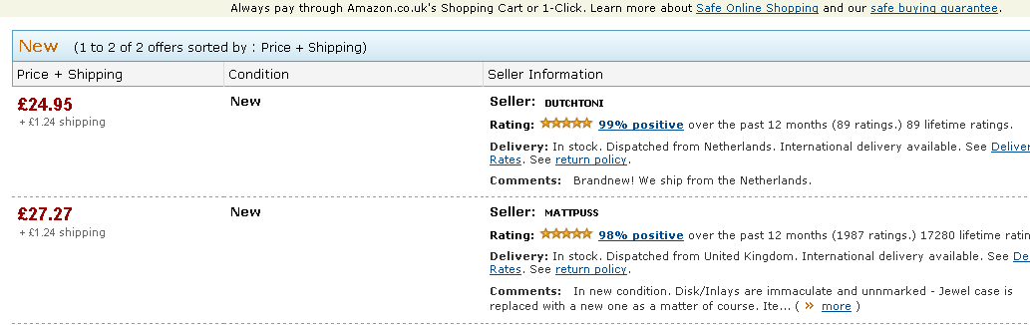
Yes it is still at a good price - £24.95 for a nearly new copy...now over to ebay for a look there- you can pick them up for round about £5 from here so good scope for profit.
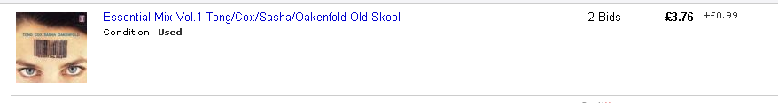
The price of this has gone up again on Amazon from around £9 to nearly £25 so you can see how prices fluctuate giving you scope for making profit if you follow the movements.

STOP PRESS: I have just done a check on Amazon.com for this item and it is getting fairly rare so the price has shot up to $66.00 plus:

This is a fantastic opportunity to buy in the UK and sell in the USA as even with shipping you will make a huge profit!
Here is a copy on ebay.co.uk for 99p starting bid:

So go and grab some copies of this and make some money before anyone else finds out!

Money Magnet Eight - Get Paid Fast – Reinvest Your Profits

Use paypal to get paid for your sales. Amazon has its own payment system which deposits your profits into your bank account. On ebay you can choose to receive payment by cheque or postal order, and whilst it is useful to have these as options it is better to have the main option as paypal. This ensures you receive the payments for your sales quickly and also ensures that the buyer receives the purchase quickly – ensuring good feedback both ways.

I also accept money orders and cheques as a last resort and you do find buyers who can only use this method of payment so don't lose sales by not being flexible.

Someone actually sent me £5.49 in cash through the post with each coin sellotaped to a card so it took me about 15 minutes to unstick it all – still it paid for a new DVD that I sold for £11.99!

Money Magnet Nine - Be Businesslike And Professional

Be businesslike and professional in all your dealings. Give the best customer service you can. Not only will this ensure great feedback but you will feel happier in your work knowing that you have done the best you can.

Ask yourself a question with every transaction – am I dealing with this in a professional and ethical manner?

If you think about the people who you either do business with or receive emails from online – who are the ones that you take notice of?

I only stay on the mailings lists of people who deliver real value and don't hit me with sales copy every time which just puts me off – I am sure you feel the same!

The best way to think about it is to say to yourself – would I do business with me?

If you can answer yes to this question then you won't go far wrong and will build up a great business.

Money Magnet Ten - Checks To Do Before Buying Stock

When buying stock either as single items or in bulk ask the seller a question first before committing. I always do this and it pays dividends. Only the other day I saw a collectable CD for sale on ebay for £3.99. I knew that it was worth £19.99 on Amazon but only if it was in reasonable condition. I emailed the seller and found that it had a couple of bad scratches but played OK. I would only be able to sell it at £4.99 in this condition so declined to buy.

However, a year ago I found a listing for a collectable CD that was described as Mint. I emailed the seller and found that he was emigrating to South Africa and needed to sell his CD collection quickly as he needed the cash. I offered him £200 for the collection which he agreed to and then sold them on Amazon as single items for £678 in total. Without asking this question I would have missed the opportunity.

Money Magnet Eleven - Make Lists – Lock In Future Profits

Make lists of the valuable items so you get a feel for what is worth buying. As with any collectable niche knowledge is power. I have spreadsheets of the most valuable items and read these regularly and recheck the prices to see how they move in the market.

Money Magnet Twelve – Buy In Bulk To Make Big Savings and Huge Profits

When you get to the stage you want to be looking at buying in bulk as the biggest profits lie here if you have the purchasing power.
The last big consignment I bought was a pallet of xbox and playstation consoles. I bought them at £3,000 and sold them online within two months at just over £8,000. I would have made much more if I had been patient and sold them as separate lots but I needed the turnover at the time for another project.
One of the pallets I bought from one of my suppliers consisted of 3,000 DVD's and the whole thing including delivery was £5,340 making each item a cost price of £1.78. Some of these DVD's sold for £1 plus postage and some sold at £34.99 plus postage. These took a lot longer to sell but overall my profit worked out at £3.50 per item. If you work that out then it equates to £10,500.
If you don't believe me look at this current offer from another supplier...

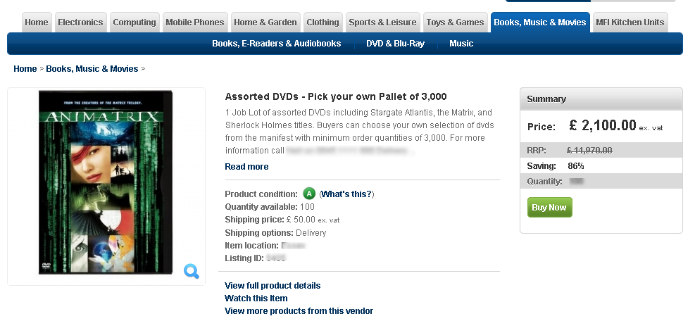
This is a different idea as you can pick your own DVD's but you get the picture!

My Secret Suppliers – Make Or Break Your Business

OK here are the suppliers that you can get rare and bulk items from if you keep up to date with their listings.

UK

http://thebidmaker.com/

http://stockshifters.com/

http://myworld.ebay.co.uk/smoggy!/

ROGERS VIDEO
Unit B1, Hilton Trading Estate, Hilton Road, Wolverhampton, WV4 6DW
Tel: 01902 495 565
Fax: 01902 353 534

USA

http://store.acousticsounds.com/
http://www.overstock.com/Books-Movies-Music-Games/Music/10/dept.html
http://www.wholesalediscs.com/mixedgenrecdcollectionsincrediblevariety.aspx
http://myworld.ebay.com/recrdhed/

You will notice that I haven't given you a massive list of suppliers. I could easily do this but I would be giving you useless information. I only deal with suppliers who provide a great service, great products and most of all value for money.

If I am honest about this I only really use thebidmaker for bulk lots and wholesale discs for collectables that I need.

Using thebidmaker is what took my business to the next level. Up until then I was making around 10 to 15 sales a day and only £20 or so profit a day. When I bought my first big consignement from thebidmaker I found so many items that sold for £20 - £30 each!! Not bad when you work out the unit cost of £1.79.

Start off with your own CD's and DVD's to build up some money fast then buy from thebidmaker to make massive profits just in time for the xmas rush!

SPECIAL SECTION ON COLLECTABLE CD’S AND DVD’S

I hope that you have followed the steps in building your business and are now well on your way to making a good second income.

This is the special section I mentioned in the sales information which led you to buy this ebook. This is probably the most valuable piece of information I could give you and in previous versions of this ebook I didn’t reveal this as I didn’t want too much competition. However, I am now making a much bigger income through other income streams and will let you know about those in the near future. So I can now let you have the best information on how to make even more money with collectable CD’s and DVD’s.

Here we go….

OK so ages ago it seems now I had made a substantial amount of money from buying and selling CD’s using amazon and ebay. However, I stumbled across a supplier called The Bidmaker. I can’t remember how I found him but it was worth its weight in gold. I decided that to make a good amount of money I needed to invest in a lot more stock and try and get it at a good price.

I did one deal with the Bidmaker and made 3 times my money back! I ended up buying about 6,000 DVD’s and CD’s in one go from him which arrived at my front door on a big pallet! Luckily I had decided to rent a shop to store the stock in so just had to break the pallet down and ship it bit by bit to the shop. This is where I found some hidden gems….

Gold Content One – Rare and Collectable CD's

CD’s – all of these were bought for an average price of £1.79 (that’s the price of everything from the pallet divided by the no of items):

What you need to do here is take a note of the title and listing ID to see what they are worth now on Amazon or eBay. Then calculate the difference to work out the profit you can make on any item.

Remember to set up the eBay alerts so you never miss a bargain.

If you do this for all of these items I can guarantee you will make a lot of money...

Order #:
Listings: 1
Total Item Count: 1
Listing 1: Now That's What I Call Music 1986 - Millennium Series [Audio CD] Various Artists

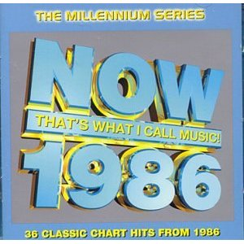
Quantity: 1
Buyer's Price: £25.99
Postage & Handling: £1.24
Total Amount: (£27.23)
Less Amazon.co.uk Marketplace Fees: (£4.14)
Less VAT on Amazon.co.uk Marketplace: (£0.63)
Total Due Seller: £22.46
PROFIT : 22.46 – 2.00 (Inc packing materials) = 20.46

Order #:
Listings: 1
Total Item Count: 1
Listing 1: Now That's What I Call Music 1989 - Millennium Series [Audio CD] Various Artists
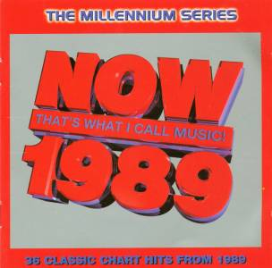
Quantity: 1
Buyer's Price: £27.99
Postage & Handling: £1.24
Total Amount: (£29.23)
Less Amazon.co.uk Marketplace Fees: (£4.44)
Less VAT on Amazon.co.uk Marketplace: (£0.67)
Total Due Seller: £24.12
PROFIT : 24.12 – 2.00 (Inc packing materials) = 22.12

Order #:
Listings: 1
Total Item Count: 1
Listing 1: Now That's What I Call Music 1986 - Millennium Series [Audio CD] Various Artists

Quantity: 1
Buyer's Price: £25.99
Postage & Handling: £3.08
Total Amount: (£29.07)
Less Amazon.co.uk Marketplace Fees:(£4.08)
Less VAT on Amazon.co.uk Marketplace: (£0.62)
Total Due Seller: £24.37
PROFIT : 24.37 – 2.00 (Inc packing materials) = 22.37

Order #:
Listings: 1
Total Item Count: 1
Listing 1: Now That's What I Call Music 1981 - Millennium Series [Audio CD] Various Artists

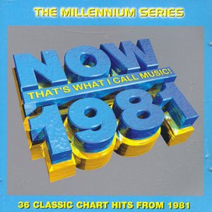
Quantity: 1
Buyer's Price: £29.99
Postage & Handling: £1.24
Total Amount: (£31.23)
Less Amazon.co.uk Marketplace Fees: (£4.74)
Less VAT on Amazon.co.uk Marketplace: (£0.72)
Total Due Seller: £25.77
PROFIT : 25.77 – 2.00 (Inc packing materials) = 23.77

This next one is 1 order for 3 collectable CD’s from one customer!
Order #:
Listings: 3
Total Item Count: 3
Listing 1: Now That's What I Call Music 1981 - Millennium Series [Audio CD] Various Artists
Quantity: 1
Buyer's Price: £29.99
Listing 2: Now That's What I Call Music 1983 - Millennium Series [Audio CD] Various Artists
Quantity: 1
Buyer's Price: £22.99
Listing 3: Now That's What I Call Music 1982 - Millennium Series [Audio CD] Various Artists
Quantity: 1
Buyer's Price: £29.99
Postage & Handling: £5.37
Total Amount: (£88.34)
Less Amazon.co.uk Marketplace Fees: (£12.87)
Less VAT on Amazon.co.uk Marketplace: (£1.94)
Total Due Seller: £73.53

PROFIT : 73.53 – 6.00 (Inc packing materials) = 67.53

Order #:
Listings: 1
Total Item Count: 1
Listing 1: Now That's What I Call Music 1983 - Millennium Series [Audio CD] Various Artists
Quantity: 1
Buyer's Price: £22.99
Postage & Handling: £1.24
Total Amount: (£24.23)
Less Amazon.co.uk Marketplace Fees: (£3.69)
Less VAT on Amazon.co.uk Marketplace: (£0.56)
Total Due Seller: £19.98

PROFIT : 19.98 – 2.00 (Inc packing materials) = 17.98

Order #:
Listings: 1
Total Item Count: 1
Listing 1: Now That's What I Call Music 1981 - Millennium Series [Audio CD] Various Artists
Quantity: 1
Buyer's Price: £19.99
Postage & Handling: £1.79
Total Amount: (£21.78)
Less Amazon.co.uk Marketplace Fees: (£3.14)
Less VAT on Amazon.co.uk Marketplace: (£0.47)
Total Due Seller: £18.17

PROFIT : 18.17 – 2.00 (Inc packing materials) = 16.17

Order #:
Listings: 2
Total Item Count: 2
Listing 1: Now That's What I Call Music 1992 - Millennium Series [Audio CD] Various Artists
Quantity: 1
Buyer's Price: £19.79
Listing 2: Now That's What I Call Music 1998 - Millennium Series [Audio CD] Various Artists
Quantity: 1
Buyer's Price: £14.95
Postage & Handling: £2.48
Total Amount: (£37.22)
Less Amazon.co.uk Marketplace Fees: (£5.69)
Less VAT on Amazon.co.uk Marketplace:(£0.87)
Total Due Seller: £30.66

PROFIT : 30.66 – 2.00 (Inc packing materials) = 28.66

Order #:
Listings: 1
Total Item Count: 1
Listing 1: Now That's What I Call Music 1984 - Millennium Series [Audio CD] Various Artists
Quantity: 1
Buyer's Price: £16.98
Postage & Handling: £1.79
Total Amount: (£18.77)
Less Amazon.co.uk Marketplace Fees: (£2.69)
Less VAT on Amazon.co.uk Marketplace:(£0.40)
Total Due Seller: £15.68

PROFIT : 15.68 – 2.00 (Inc packing materials) = 13.68

Order #:
Listings: 1
Total Item Count: 1
Listing 1: Now That's What I Call Music 1988 - Millennium Series [Audio CD] Various Artists
Quantity: 1
Buyer's Price: £25.99
Postage & Handling: £1.79
Total Amount: (£27.78)
Less Amazon.co.uk Marketplace Fees: (£4.04)
Less VAT on Amazon.co.uk Marketplace:(£0.61)
Total Due Seller: £23.13

PROFIT : 23.13 – 2.00 (Inc packing materials) = 21.13

Other great CD titles:

Order #:
Listings: 1
Total Item Count: 1
Listing 1: Deeper Shades of Euphoria Vol.1: Mixed By Jay Burnett [Audio CD] Various Artists
Quantity: 1
Buyer's Price: £5.89

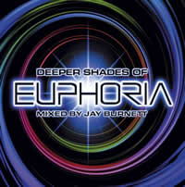

Order #:
Listings: 1
Total Item Count: 1
Listing 1: Extreme Euphoria Vol.1: Mixed By Bk/Parental Advisory [Audio CD] Various...
Quantity: 1
Buyer's Price: £8.48

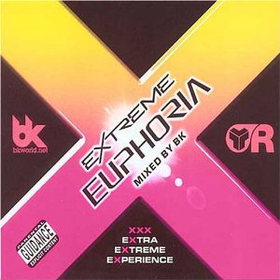

Order #:
Listings: 1
Total Item Count: 1
Listing 1: Behind the Sun [CD + DVD] [Audio CD] Chicane
Quantity: 1
Buyer's Price: £6.49



Order #:
Listings: 1
Total Item Count: 1
Listing 1: Chilled Ibiza Vol.1 [Audio CD] Various Artists
Quantity: 1
Buyer's Price: £8.99



Order #:
Listings: 1
Total Item Count: 1
Listing 1: Global Underground: Sander Kleinenberg - Nu Breed 4 [Double CD] [Audio CD...
Quantity: 1
Buyer's Price: £9.66

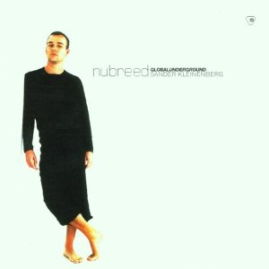
Order #:
Listings: 2
Total Item Count: 2
Listing 1: Now That's What I Call Music 1992 - 10th Anniversary [Audio CD] Various Artists
Quantity: 1
Buyer's Price: £19.99
Listing 2: Now That's What I Call Music 1983 - 10th Anniversary [Audio CD] Various Artists
Quantity: 1
Buyer's Price: £19.99

Order #:
Listings: 1
Total Item Count: 1
Listing 1: Very Best Of Euphoria (Limited Edition) [Audio CD] Various Artists
Quantity: 1
Buyer's Price: £5.48

Order #:
Listings: 1
Total Item Count: 1
Listing 1: Message in a Box [Box set] [Audio CD] Police
Quantity: 1
Buyer's Price: £15.99

Order #:
Listings: 1
Total Item Count: 1
Listing 1: Global Underground 10: Danny Tenaglia Live In Athens [Audio CD] Tenaglia, Danny
Quantity: 1
Buyer's Price: £8.98
Order #:
Listings: 1
Total Item Count: 1
Listing 1: Global Underground 8: Nick Warren Live In Brazil [Audio CD] Warren, Nick
Quantity: 1
Buyer's Price: £9.98

Order #:
Listings: 1
Total Item Count: 1
Listing 1: Global Underground 6: John Digweed Live In Sydney [Double CD] [Audio CD...
Quantity: 1
Buyer's Price: £9.37

Order #:
Listings: 1
Total Item Count: 1
Listing 1: Essential Mix Vol.1: Tong/Cox/Sasha/Oakenfold [Audio CD] Various Artists
Quantity: 1
Buyer's Price: £22.61

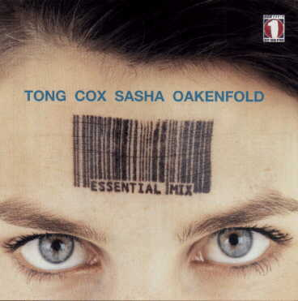

Order #:
Listings: 1
Total Item Count: 1
Listing 1: BBC Sessions [Import] [Audio CD] Bowie, David
Quantity: 1
Buyer's Price: £9.49

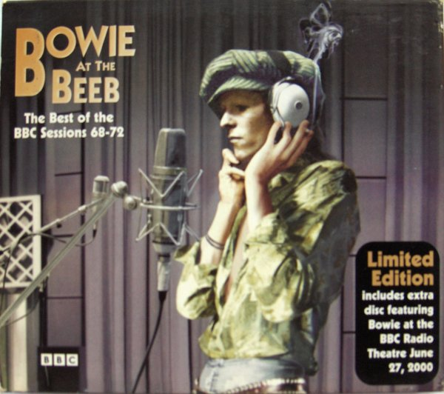

Order #:
Listings: 2
Total Item Count: 2
Listing 1: Now That's What I Call Music 1992 - Millennium Series [Audio CD] Various Artists
Quantity: 1
Buyer's Price: £19.79
Listing 2: Now That's What I Call Music 1998 - Millennium Series [Audio CD] Various Artists
Quantity: 1
Buyer's Price: £14.95

Order #:
Listings: 1
Total Item Count: 1
Listing 1: Global Underground: Seb Fontaine - Prototype 2 [Audio CD] Fontaine, Seb
Quantity: 1
Buyer's Price: £8.43

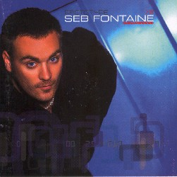

Gold Content Two – Rare and Collectable DVD's

DVD’s - this is just one example of a collectable title that sold for up to £29.99 – once again an excellent profit on the purchase price!

Order #:
Listings: 1
Total Item Count: 1
Listing 1: Transformers - Robots In Disguise [DVD] (2005) Transformers
Quantity: 1
Buyer's Price: £16.94
Postage & Handling: £1.79
Total Amount: (£18.73)
Less Amazon.co.uk Marketplace Fees: (£2.81)
Less VAT on Amazon.co.uk Marketplace: (£0.42)
Total Due Seller: £15.50
PROFIT : 15.50 – 2.00 (Inc packing materials) = 13.50
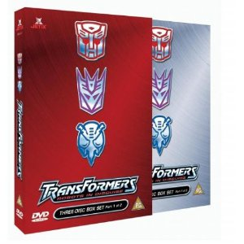

Order #:
Listings: 2
Total Item Count: 2
Listing 1: Transformers - Robots In Disguise [DVD] (2005) Transformers
Quantity: 1
Buyer's Price: £16.94
Listing 2: Transformers - Robots In Disguise [DVD] (2004) Transformers
Quantity: 1
Buyer's Price: £19.15
Postage & Handling: £3.58
Total Amount: (£39.67)
Less Amazon.co.uk Marketplace Fees: (£5.95)
Less VAT on Amazon.co.uk Marketplace: (£0.89)
Total Due Seller: £32.8

PROFIT : 32.83 – 4.00 (Inc packing materials) = 28.83

Order #:
Listings: 1
Total Item Count: 1
Listing 1: Transformers - Robots In Disguise [DVD] (2005) Transformers
Quantity: 1
Buyer's Price: £16.94
Postage & Handling: £1.24
Total Amount: (£18.18)
Less Amazon.co.uk Marketplace Fees: (£2.68)
Less VAT on Amazon.co.uk Marketplace: (£0.40)
Total Due Seller: £15.10

PROFIT : 15.10 – 2.00 (Inc packing materials) = 13.10

Order #:
Listings: 1
Total Item Count: 1
Listing 1: Transformers - Robots In Disguise [DVD] (2005) Transformers
Quantity: 1
Buyer's Price: £18.78
Postage & Handling: £1.24
Total Amount: (£20.02)
Less Amazon.co.uk Marketplace Fees: (£2.96)
Less VAT on Amazon.co.uk Marketplace: (£0.44)
Total Due Seller: £16.62

PROFIT : 16.62 – 2.00 (Inc packing materials) = 14.62

Order #:
Listings: 2
Total Item Count: 2
Listing 1: Transformers - Robots In Disguise [DVD] (2004) Transformers
Quantity: 1
Buyer's Price: £29.99
Listing 2: Transformers - Robots In Disguise [DVD] (2005) Transformers
Quantity: 1
Buyer's Price: £18.94
Postage & Handling: £7.16
Total Amount: (£56.09)
Less Amazon.co.uk Marketplace Fees: (£8.90)
Less VAT on Amazon.co.uk Marketplace:(£1.35)
Total Due Seller: £45.84

PROFIT : 45.84 – 4.00 (Inc packing materials) = 41.84

Order #:
Listings: 1
Total Item Count: 1
Listing 1: Transformers - Robots In Disguise [DVD] (2005) Transformers
Quantity: 1
Buyer's Price: £21.80
Postage & Handling: £1.79
Total Amount: (£23.59)
Less Amazon.co.uk Marketplace Fees: (£3.54)
Less VAT on Amazon.co.uk Marketplace:(£0.53)
Total Due Seller: £19.52

PROFIT : 19.52 – 2.00 (Inc packing materials) = 17.52

Order #:
Listings: 2
Total Item Count: 2
Listing 1: Transformers - Robots In Disguise [DVD] (2004) Transformers
Quantity: 1
Buyer's Price: £16.99
Listing 2: Transformers - Robots In Disguise [DVD] (2005) Transformers
Quantity: 1
Buyer's Price: £21.80
Postage & Handling: £6.16
Total Amount: (£44.95)
Less Amazon.co.uk Marketplace Fees: (£6.98)
Less VAT on Amazon.co.uk Marketplace: (£1.05)
Total Due Seller: £36.92

PROFIT : 36.92 – 2.00 (Inc packing materials) = 34.92

Other great DVD Titles to look out for:

Order #:
Listings: 1
Total Item Count: 1
Listing 1: British Rally Championship 2005 [DVD] (2005)
Quantity: 1
Buyer's Price: £6.95

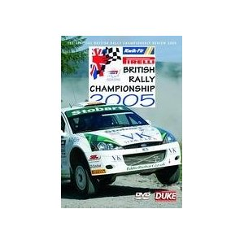
Order #:
Listings: 1
Total Item Count: 1
Listing 1: Divergence Eve - Vol. 3 [DVD] (2005) Yumi Kakazu; Fumie Mizusawa; Hiroyuki...
Quantity: 1
Buyer's Price: £6.27

Order #:
Listings: 1
Total Item Count: 1
Listing 1: Rangers: Definitive History [2001] [DVD] (2001) Rangers Fc
Quantity: 1
Buyer's Price: £6.69

Order #:
Listings: 1
Total Item Count: 1
Listing 1: Extreme Snowboard [DVD] (2005)
Quantity: 1
Buyer's Price: £6.21

Order #:
Listings: 1
Total Item Count: 1
Listing 1: Alias: Complete Season 1 [2002] [DVD] (2003) Jennifer Garner; Michael Vartan...
Quantity: 1
Buyer's Price: £10.98


Order #:
Listings: 1
Total Item Count: 1
Listing 1: The Waltons - Series 1 - Complete [DVD] (2004) Ronnie Claire Edwards; Richard...
Quantity: 1
Buyer's Price: £14.99

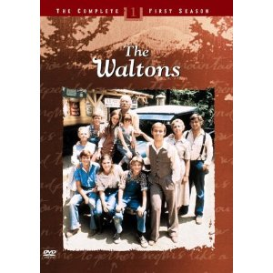
Order #:
Listings: 1
Total Item Count: 1
Listing 1: Ivan The Terrible - Prokofiev [DVD] (2005) Irek Mukhamedov; Natalya...
Quantity: 1
Buyer's Price: £7.95

Conclusion

If you do some research you can find other titles that are in huge demand on Amazon from collectors. Obviously a lot of the titles I had were from the bulk purchase I made and I don’t expect you to be able to outlay over £10,000 until you have made this from your own sales and purchases!

I use car boot sales, cash converters and second hand shops, charity shops and also ebay to find hidden gems. You need to spend a bit of time looking through the listings on Amazon to see what items are in demand and bringing in good money. Then make a list of the titles that you have found so you can take these with you on your travels. Also keep a look out daily on ebay for listings of these titles. A lot of sellers don’t realise what they are selling so you can pick up some good ones. The best listings I have found on ebay are ones that end during the day rather than the weekend. Savvy sellers end their auctions between 6pm and 10pm when they know that lots of people are looking.

So get started on your research now and find the titles I have shown you and look for others as I have explained. It pays in the long run to do a lot of research and make a spreadsheet of prices so you know what the market will take. I have included a spreadsheet of Now Music prices for you to use as a basis for your research and to give you a head start in locating some gems. I haven’t released this extra information before as I didn’t want too many competitors in the market! However, as I am now making better money in other areas I am happy to help you get started.

One last tip:

Don’t waste this information and just forget about it. If you take action and make this work you will create a substantial second income and who knows if you make enough you can give up your current job.

Best of luck

